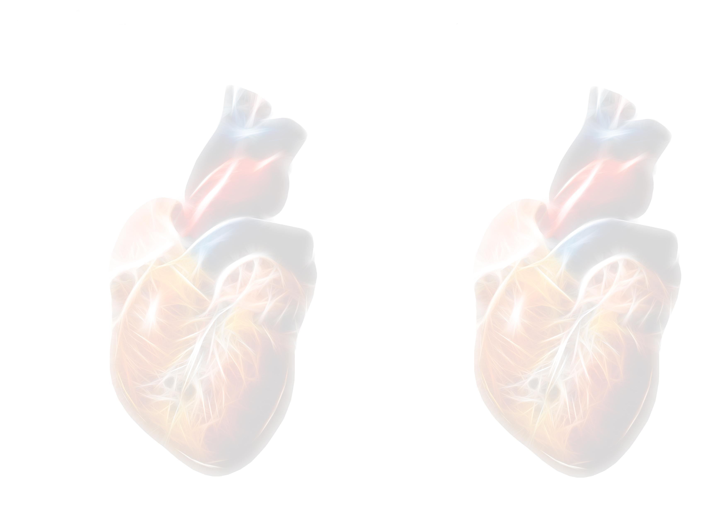
Levitronix Master Class
 | (30) 0800-0830 | Registration
張效煌 | (10) 0830-0840 | Welcome and Introduction
Carole Kelly | (10) 0840-0850 | CentriMag System Overview
INITIAL PATIENT ASSESSMENTS-
張效煌 | (10) 0850-0900 | Patient Selection-post cardiotomy cardiogenic shock, AMI, decompensated HF
Holger Buchholz | (10) 0900-0910 | Patient Assessment-echo, blood work, hemodynamics, neuro status, secondary organ function
 | (15) 0910-0925 | Discussion
ANESTHESIA & SURGERY-
宋俊松 | (10) 0925-0935 | Anesthetic Considerations
張效煌 | (10) 0935-0945 | Surgical Technique & Cannulation Options-on or off bypass, atrial or ventricular cannulation, cannulae choices
林素滿 | (10) 0945-0955 | Intra-Operative ECHO and Right Heart Failure, LVAD vs BiVAD
 | (15) 0955-1010 | Discussion
 | (20) 1010-1030 | Coffee-Break
POST OPERATIVE MANAGEMENT-
陳益祥 | (10) 1030-1040 | Right Heart Failure and Early Post Operative ICU Management
Holger Buchholz | (10) 1040-1050 | Anticoagulation Management-assessment, strategies and HIT

Holger Buchholz | (10) 1050-1100 | Infection: General Considerations and Strategies for Prevention
 | (15) 1100-1115 | Discussion
CLINICAL EXPERIENCE OF LEVITRONIX
陳益祥 | (10) 1115-1125 | Clinical Experience of National Taiwan University Hospital
鄭伯智 | (10) 1125-1135 | Clinical Experience of Chi Mei Medical Center
張效煌 | (10) 1135-1145 | Clinical Experience of Taipei Veterans General Hospital
Holger Buchholz | (20) 1145-1205 | Clinical Experience of Hospital of University of Alberta
1205-1300 | Lunch
LONGER TERM MANAGEMENT-
張效煌 | (15) 1300-1315 | Assessment of Recovery
Holger Buchholz | (15) 1315-1330 | Surgical Explanation-Weaning, Upgrading, or Transplantation
 | (30) 1330-1400 | Discussion
1400-1600 | Surgical Wet Lab and Priming Demonstration
1600 | Discussion & Closing Remarks

