Recent Advances in the Surgical Treatments of Aortic Dissection
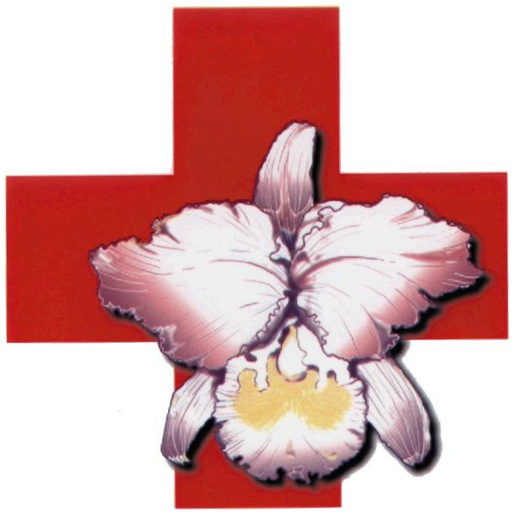
Live Demonstration

Second Announcement
Date: 6th May, 2012
Cheng Hsin General Hospital
Taiwan Association of Thoracic and Cardiovascular Surgery
Venue: 5F International Conference Room, Cheng Hsin General Hospital
45 Cheng Hsin Street, Beitou, Taipei, 112, Taiwan
主辦單位：振興醫院心臟醫學中心
協辦單位：臺灣胸腔及心臟血管外科學會
學分申請：中華民國心臟學會、中華民國體外循環技術學會、台灣血管外科醫學會、台灣胸腔及心臟血管外科學會、台灣外傷醫學會、中華民國護理師護士公會全國聯合會
地點：振興醫院五樓國際會議中心（臺北市北投區振興街45號）

May6, 2012 (Sunday)
International Conference Room
CHENG HSIN LIVE SURGERY ON AORTIC DISSECTION
0730-0810 | Registration
0810-0825  0825-0830 | Welcome Address  Opening Remarks | 李壽東 院長、楊友任 理事長  魏 崢 教授
0830-0900 | Special Lecture 1  Aortic Surgery | Moderator: Jeng Wei (魏 崢)  Speaker: Allan Stewart
0900-0920 | Special Lecture 2  Open Surgery for Aortic Dissection | Moderator: Chun-Che Shih (施俊哲)  Speaker: Jeng Wei (魏 崢)
0920-0940 | Special Lecture 3  Endovascular Surgery for Aortic Dissection | Moderator: Chaw-Chi Chiu (邱肇基)  Speaker: Chun-Che Shih(施俊哲)
0940-1240 | Video Sessions  Endovascular Surgery for Aortic Dissection | Moderator: Chung-Yi Chang (張忠毅)  Chien-Sung Tsai (蔡建松)  Speaker: Chun-Che Shih(施俊哲)  Po-Jen Ko (柯博仁)  Chia-Hsun Lin (林佳勳)  I-Hui Wu (吳毅暉)  Huai-Hsu Huang (黃懷緒)
0940-1240 | Live Demonstration I：  Vascular Ring Connector for Aortic Dissection  Operation Room 1 & 2 | Moderator: Chung-Yi Chang (張忠毅)  Chien-Sung Tsai (蔡建松)  Operator : Jeng Wei (魏 崢)  Commentators: Pyng-Jing Lin (林萍章)  Shaw-Min Hou (侯紹敏)  Chia-Hsun Lin (林佳勳)  Kuan-Ming Chiu (邱冠明)
1240-1320 | Lunch
1320-1620 | Live Demonstration II：  Endovascular Surgery for Aortic Dissection  Operation Room 3 (Hybrid) | Moderator: Yih-Sharng Chen (陳益祥)  Yi-Cheng Chung(莊義成)  Supervisor: Allan Stewart  Po-Jen Ko (柯博仁)  Operator : Sung-How Sue(蘇上豪)  Huai-Hsu Huang (黃懷緒)  Commentators: Chien-Sung Tsai (蔡建松)  Shih Rong Hsieh (謝世榮)  I-Ming Chen(陳沂名)  I-Hui Wu (吳毅暉)
1620-1700 | Discussion | Moderators: Allan Stewart
1750-1800 | Closing Remarks | 楊友任 理事長
1800-2030 | Dinner

